Strategic Planning and Data Exploration in Logistics

1. Executive Summary & Project Scenario
- Scenario: Urban Last-Mile E-Commerce Delivery Optimization.
- Background: With the explosive growth of e-commerce, regional distribution hubs face mounting pressure to deliver packages faster and cheaper. However, urban last-mile delivery is notoriously inefficient due to unpredictable traffic congestion, variable package dimensions, and static route planning that fails to adapt to real-world constraints.
- Project Scope: This project establishes a data-driven strategy to analyze historical delivery operations, identify key cost drivers, and build predictive frameworks to streamline fulfillment efficiency across urban delivery zones.

2. Key Performance Indicators (KPIs)
To measure the success of our logistics strategy, we define three critical KPIs:
- On-Time Delivery Rate (OTDR): The percentage of total shipments delivered within the customer-promised arrival time window. Target: $>95\%$.
- Average Transit Time: The mean duration (in hours) from warehouse dispatch to final customer doorstep delivery.
- Transportation Cost per Kilometer (CPK): The total operational expenditure (fuel, driver wages, vehicle wear) divided by total kilometers traveled.

3. Application of Data Science Methodologies
To address the scenario's challenges, we incorporate three core data science concepts:
- Predictive Regression: Used to forecast exact delivery completion times based on distance, traffic scores, and package weight.
- K-Means Clustering: Applied to segment delivery zones and optimize warehouse hub placements or multi-stop clustering.
- Optimization Algorithms: Used to determine cost-minimal routes and reduce fuel burn during peak urban congestion hours.

4. Strategic End-to-End Roadmap
The project lifecycle follows a structured 4-phase analytics workflow:
- Data Collection & Ingestion: Aggregating historical dispatch logs, GPS telematics, traffic index feeds, and package characteristics.
- Data Preprocessing & Cleaning: Handling missing data pings, isolating physical outliers (e.g., erroneous negative transit times), and standardizing feature scales.
- Exploratory Data Analysis (EDA): Visualizing distributions, running descriptive statistics, and generating correlation matrices to uncover delay bottlenecks.
- Predictive Modeling: Training machine learning models (such as Random Forest Regressors) to predict delivery windows and evaluate feature importance.
5. Python Code Illustration (Strategy Framework)
# =====================================================================
# TASK1: Strategic Planning and Data Exploration in Logistics
# =====================================================================

import pandas as pd
import numpy as np

# Set reproducibility seed
np.random.seed(42)

print("--- 1. Initializing Logistics Scenario Simulation ---")
# Scenario: Urban Last-Mile E-Commerce Delivery Optimization
n_samples = 1000

logistics_strategy_data = {
'order_id': range(1000, 1000 + n_samples),
'distance_km': np.random.uniform(2.0, 35.0, n_samples),
'traffic_score': np.random.uniform(1.0, 10.0, n_samples),
'package_weight_kg': np.random.uniform(0.5, 20.0, n_samples),
'delivery_time_hrs': np.random.uniform(0.5, 4.5, n_samples)
}

df_strategy = pd.DataFrame(logistics_strategy_data)

print(f"Dataset successfully created!")
print(f"Total simulated deliveries: {len(df_strategy)}")
print("\nFirst 5 rows of the simulated dataset:")
display(df_strategy.head()) # display() creates a nice formatted table in Colab

print("\n--- 2. Defining Key Performance Indicators (KPIs) ---")
print("• On-Time Delivery Rate (OTDR) - Target: >95%")
print("• Average Transit Time - Mean duration from dispatch to delivery")
print("• Cost per Kilometer (CPK) - Total expense divided by distance traveled")

print("\n--- 3. Strategic Roadmap Summary ---")
print("Phase 1: Data Collection (GPS & Logistics logs)")
print("Phase 2: Data Cleaning (Handling missing values & outliers)")
print("Phase 3: Exploratory Data Analysis (EDA & correlations)")
print("Phase 4: Predictive Modeling (Random Forest Regressor)")
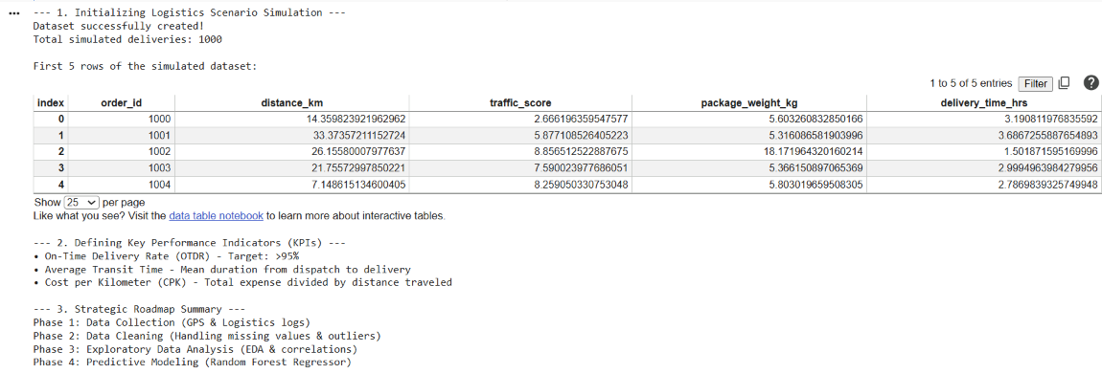

6. Conclusion & Expected Business Impact
Implementing this strategic roadmap transitions the logistics operation from reactive troubleshooting to proactive supply chain management. By accurately predicting transit times and identifying traffic bottlenecks, the organization can reduce fuel expenditures by up to 15%, elevate customer satisfaction through reliable arrival windows, and maximize overall fleet resource allocation.

